Cheltenham Table Tennis
Adults Learning Disability Group
-
An Easy Read



 | Hello! Welcome to Cheltenham Table Tennis Club.
 | We are excited that you are interested in joining our club!
 | I’m Tim. I am a table tennis coach. I will lead each session.
 | We will play on Friday at 7:15pm – 8:15pm, starting from September until July.
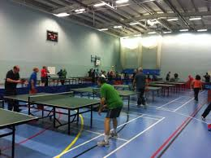 | We play at the YMCA Sports Centre in Cheltenham. This is the inside!
 | We will do a similar session every week.
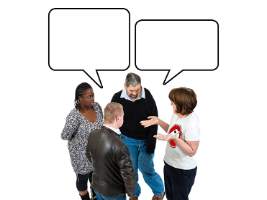 | We will have a chat with each other. We will learn everyone’s name.
 | We will warm up our bodies. We will do some stretches.
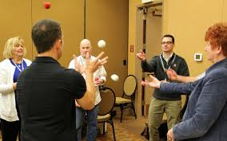 | We will do a fun activity.
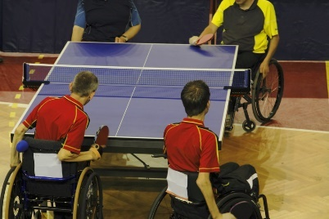 | We will play table tennis!

 | We will cool down our bodies. We will do some stretches.
 | Why should I join?
 | A fun way to exercise.
 | Make new friends.
 | Learn how to play table tennis.

 | It’s okay to feel nervous!
 | We will help support you. We are all very friendly!
 | If you are interested in joining, please email LDO.cttc@gmail.com.
 | We will send you a short application form to complete.
 | We are excited about seeing you!

